 

Embedded Systems Professional Track EgFWD - Udacity

On-demand Traffic Light control

Project Documentation

By:

Mohammed alaa

# Table of Contents

Table of Contents II

1. System Description 3
   1. System Overview 3
   2. System Functionality 3
2. System Design 4
   1. System Requirements 4
   2. Operating Environment 4
   3. Input & Output Formats 4
3. System constraints 5
4. Flow Chart 5

# System Description

## System OverviewC:\Users\hp\Pictures\Screenshots\Screenshot (107).png

The system aims to provide an on-demand traffic control system. It includes a pedestrian button to allow for pedestrians to pass.

Constraints:

-can configure pin by pin only

-timer work in normal mode

-work in external interrupt 0 only

## System Functionality

The system can detect when the button is pressed. Afterwards, based on current state it would decide what to do. It allows pedestrians to walk by making sure cars are stopped first.

# System Design

## System Requirements

The system consists of:

* + - AVR Atmega32 (1MHz)
    - 2 Green LEDs
    - 2 Yellow LEDs
    - 2 Red LEDs
    - 1 Push Button

## Operating Environment

The program has been tested on Proteus simulator provided by LabCenter. It should be used in traffic light control systems on streets with a pedestrian push button included to allow for full system functionality.

## Input & Output Formats

The only system input is in the form of the pedestrian push button. When it comes to output it handles 6 LEDs at once given the current state, time and push button press state.

# System Constraints:

* the pedestrian when he make a short press on the crosswalk button while the cars red light is on

And pedestrian green light is on, ***nothing to is done***

* The pedestrian when make a long press on the crosswalk button, ***nothing to is done***.
* The pedestrian when he made a double press on the crosswalk button, ***the first press will do***

***The action and nothing is done after the second press.***

# 4.Flow Chart

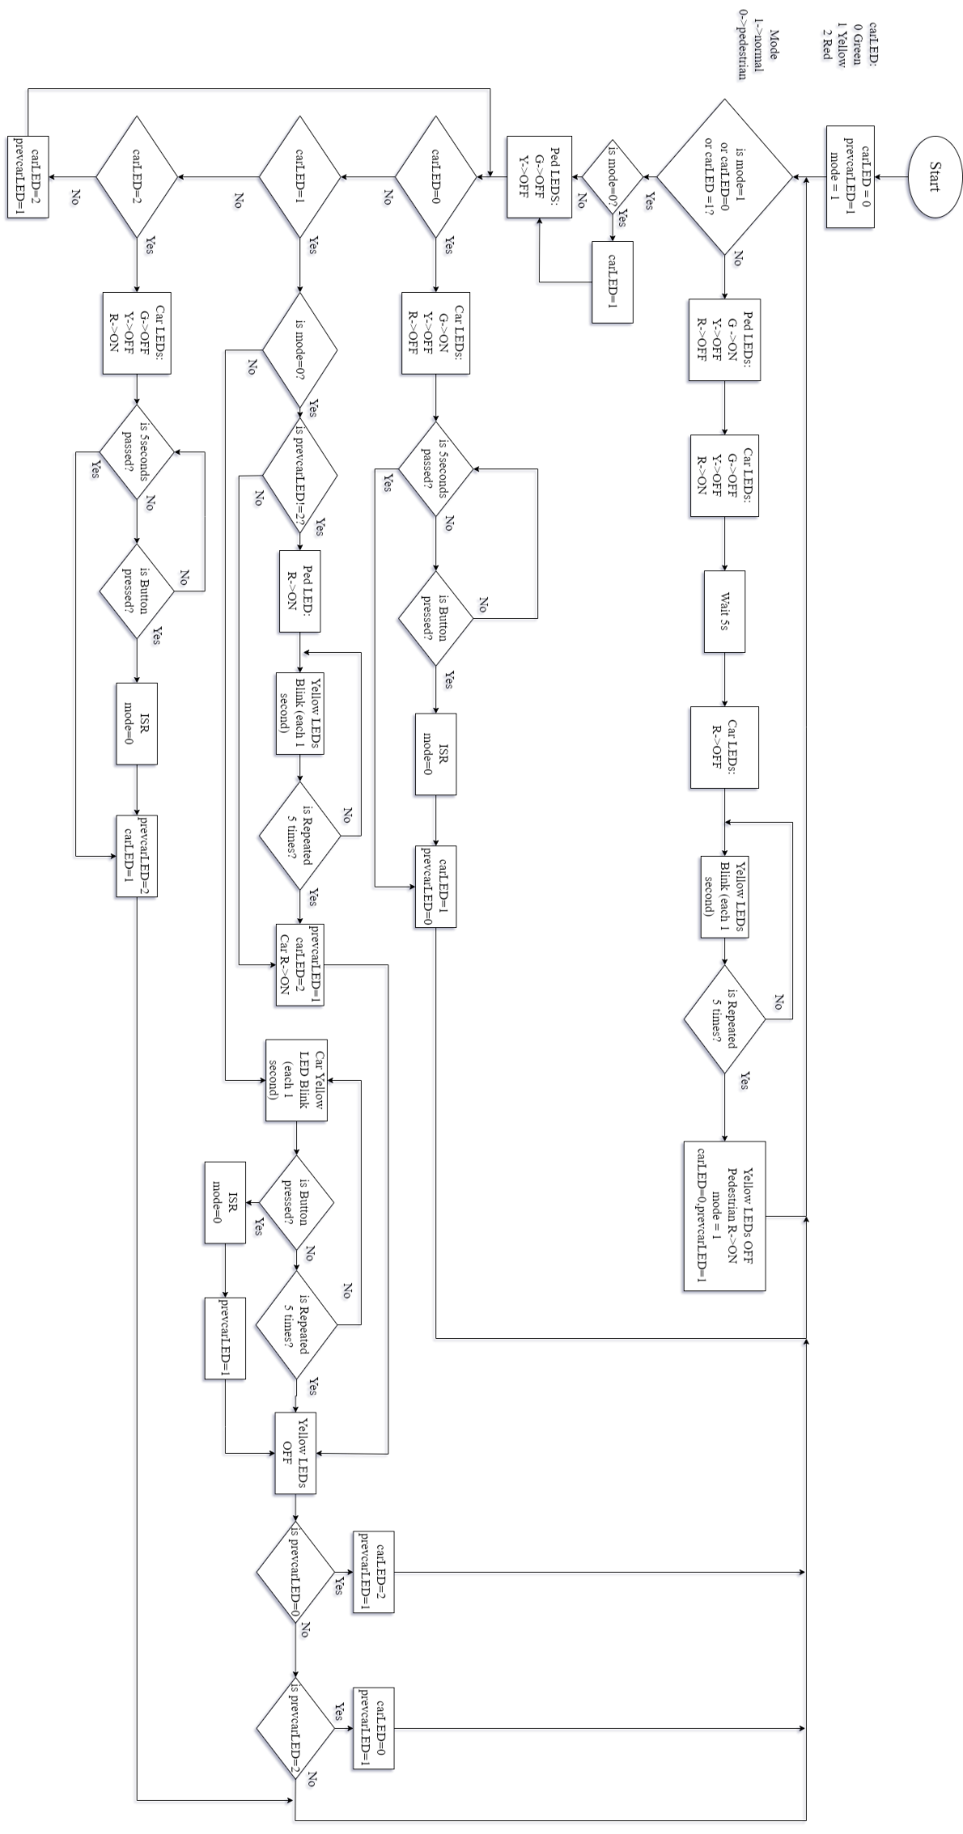

5

# 5.System Layer:

